Project1-Rivera
M.Rivera

Life Expectancy Trends in Kuwait Compared to the United States

Section 1: Introduction
Found in the Middle East, Kuwait has gone through quick social and economic change in recent years (WHO, 2023; Mokdad et al., 2016). Despite its economic prosperity and oil wealth, the country faces public health issues due to a high and rising prevalence of noncommunicable diseases, such as obesity, diabetes, and cardiovascular disease (Mokdad et al., 2016; Ng et al., 2014). Even while health care spending is high, its economic benefits are not always matched by health results (Anderson et al., 2003; Deaton, 2013).
We examine the relationship between economic prosperity and population health in various social and health system contexts, especially looking at GDP per capita and life expectancy, in comparison to the United States.

Section 2: Data Preparation & Descriptive Exploration

Filter the Data
library(tidyverse)
── Attaching core tidyverse packages ──────────────────────── tidyverse 2.0.0 ──
✔ dplyr 1.1.4 ✔ readr 2.1.6
✔ forcats 1.0.1 ✔ stringr 1.6.0
✔ ggplot2 4.0.1 ✔ tibble 3.3.1
✔ lubridate 1.9.4 ✔ tidyr 1.3.2
✔ purrr 1.2.1
── Conflicts ────────────────────────────────────────── tidyverse_conflicts() ──
✖ dplyr::filter() masks stats::filter()
✖ dplyr::lag() masks stats::lag()
ℹ Use the conflicted package (<http://conflicted.r-lib.org/>) to force all conflicts to become errors
library(gapminder)
gapminder
# A tibble: 1,704 × 6
country continent year lifeExp pop gdpPercap
<fct> <fct> <int> <dbl> <int> <dbl>
1 Afghanistan Asia 1952 28.8 8425333 779.
2 Afghanistan Asia 1957 30.3 9240934 821.
3 Afghanistan Asia 1962 32.0 10267083 853.
4 Afghanistan Asia 1967 34.0 11537966 836.
5 Afghanistan Asia 1972 36.1 13079460 740.
6 Afghanistan Asia 1977 38.4 14880372 786.
7 Afghanistan Asia 1982 39.9 12881816 978.
8 Afghanistan Asia 1987 40.8 13867957 852.
9 Afghanistan Asia 1992 41.7 16317921 649.
10 Afghanistan Asia 1997 41.8 22227415 635.
# ℹ 1,694 more rows
# Filter data for Kuwait
kuwait_df <- gapminder %>%
filter(country == "Kuwait")
kuwait_df
# A tibble: 12 × 6
country continent year lifeExp pop gdpPercap
<fct> <fct> <int> <dbl> <int> <dbl>
1 Kuwait Asia 1952 55.6 160000 108382.
2 Kuwait Asia 1957 58.0 212846 113523.
3 Kuwait Asia 1962 60.5 358266 95458.
4 Kuwait Asia 1967 64.6 575003 80895.
5 Kuwait Asia 1972 67.7 841934 109348.
6 Kuwait Asia 1977 69.3 1140357 59265.
7 Kuwait Asia 1982 71.3 1497494 31354.
8 Kuwait Asia 1987 74.2 1891487 28118.
9 Kuwait Asia 1992 75.2 1418095 34933.
10 Kuwait Asia 1997 76.2 1765345 40301.
11 Kuwait Asia 2002 76.9 2111561 35110.
12 Kuwait Asia 2007 77.6 2505559 47307.
# Filter data for United States
us_df <- gapminder %>%
filter(country == "United States")
us_df
# A tibble: 12 × 6
country continent year lifeExp pop gdpPercap
<fct> <fct> <int> <dbl> <int> <dbl>
1 United States Americas 1952 68.4 157553000 13990.
2 United States Americas 1957 69.5 171984000 14847.
3 United States Americas 1962 70.2 186538000 16173.
4 United States Americas 1967 70.8 198712000 19530.
5 United States Americas 1972 71.3 209896000 21806.
6 United States Americas 1977 73.4 220239000 24073.
7 United States Americas 1982 74.6 232187835 25010.
8 United States Americas 1987 75.0 242803533 29884.
9 United States Americas 1992 76.1 256894189 32004.
10 United States Americas 1997 76.8 272911760 35767.
11 United States Americas 2002 77.3 287675526 39097.
12 United States Americas 2007 78.2 301139947 42952.
# Filter dataset for both
compare_df <- gapminder %>%
filter(country %in% c("Kuwait", "United States"))
compare_df
# A tibble: 24 × 6
country continent year lifeExp pop gdpPercap
<fct> <fct> <int> <dbl> <int> <dbl>
1 Kuwait Asia 1952 55.6 160000 108382.
2 Kuwait Asia 1957 58.0 212846 113523.
3 Kuwait Asia 1962 60.5 358266 95458.
4 Kuwait Asia 1967 64.6 575003 80895.
5 Kuwait Asia 1972 67.7 841934 109348.
6 Kuwait Asia 1977 69.3 1140357 59265.
7 Kuwait Asia 1982 71.3 1497494 31354.
8 Kuwait Asia 1987 74.2 1891487 28118.
9 Kuwait Asia 1992 75.2 1418095 34933.
10 Kuwait Asia 1997 76.2 1765345 40301.
# ℹ 14 more rows

Descriptive Statistics
# Kuwait
mean_lifeExp_kw <- mean(kuwait_df$lifeExp)
sd_lifeExp_kw <- sd(kuwait_df$lifeExp)
n_years_kw <- length(unique(kuwait_df$year))
Across ‘r n_years_kw’ years of available data, the mean life expectancy in Kuwait was ‘r mean_lifeExp_kw’ years (SD = ‘r sd_lifeExp_kw’).
mean_lifeExp_us <- mean(us_df$lifeExp)
sd_lifeExp_us <- sd(us_df$lifeExp)
n_years_us <- length(unique(us_df$year))
Across ‘r n_years_us’ years of available data, the mean life expectancy in the United States was ‘r mean_lifeExp_us’ years (SD = `r sd_lifeExp_us’).
##Section 3: Visualizations

Life Expectancy Over Time - Kuwait vs U.S.
ggplot(compare_df,
aes(
x = year,
y = lifeExp,
color = country)
) +
geom_line () +
geom_point() +
labs(
title = "Life Expectancy Over Time: Kuwait vs United States",
x = "Year",
y = "Life Expectancy (years)",
color = "Country"
)
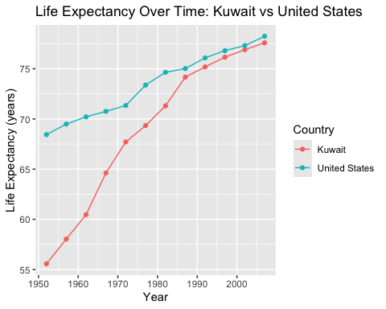
Between 1952 and 2007, both Kuwait and the US had steady increases in life expectancy. Kuwait saw faster increases, especially from the 1960s through the 1980s, whereas the United States maintained a steadily greater life expectancy throughout the research period. This trend indicates that Kuwait had a period of rapid health improvement, which was probably brought on by improvements in living circumstances, increased access to healthcare, and economic prosperity (Cutler et al., 2006; Marmot, 2005). Even with these improvements, Kuwait’s life expectancy by 2007 did not completely match that of the United States.

GDP Per Capita vs Life Expectancy
ggplot(compare_df,
aes(
x = gdpPercap,
y = lifeExp,
color = country)
) +
geom_point() +
scale_x_log10() +
labs(
title = "Life Expectancy vs GDP per Capita: Kuwait vs United States",
x = "GDP per Capita (log scale)",
y = "Life Expectancy (years)",
color = "Country"
)
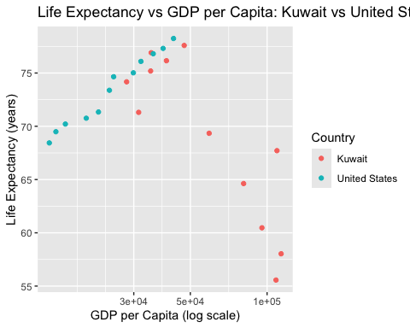
For both Kuwait and the US, life expectancy is often greater in countries with higher GDP per capita. At equivalent or greater levels of economic production, Kuwait’s life expectancy is still lower than that of the US, suggesting that population health is not only determined by economic well-being (Marmot, 2005; Deaton, 2013). This research emphasizes the significance of the allocation and investment of resources in social services, health systems, and preventative care. The observed disparity may also be caused by variations in healthcare access, chronic illness load, and health practices (Mokdad et al., 2016).

Section 4: Data Quality & Limitations
Life expectancy, population, and GDP per capita for Kuwait and the US are all complete in the Gapminder data-set utilized in this research, allowing for reliable descriptive comparisons over time; however, the capacity to analyze current trends in population health or short-term changes is limited because the data are only available for observations made every five years between 1952 and 2007.
Furthermore, because all metrics are presented as national averages, within-country differences in socioeconomic level, gender, race, or immigration status are not captured (Deaton, 2013; Marmot, 2005). The dataset’s capacity to explain observed variations in life expectancy is further limited by its absence of data on healthcare systems, disease-specific mortality, and policy initiatives; therefore, rather than being causative, the results of this research should be understood as descriptive.

Section 5: Reflection
Being able to accurately relay information in R and convert descriptive data and visuals into understandable public health findings was a rewarding experience. One interesting finding was that despite Kuwait’s high GDP per capita, life expectancy increased quickly during times of economic boom and the country continued to lag behind the US. This somewhat unexpected conclusion supports the notion that economic expansion by itself does not provide the best possible outcomes for population health (Marmot, 2005; Deaton, 2013). If more information were available, I would like to investigate the ways in which the structure of the healthcare system, the frequency of chronic diseases, and the dynamics of the population affect the variations in life expectancy among high-income nations. The importance of descriptive research as a starting point for more complex analysis was understood well doing this project.

References
Anderson, G. F., Reinhardt, U. E., Hussey, P. S., & Petrosyan, V. (2003). It’s the prices, stupid: Why the United States is so different from other countries. Health Affairs, 22(3), 89–105. https://www.healthaffairs.org/doi/10.1377/hlthaff.22.3.89
The determinants of mortality. Journal of Economic Perspectives, 20(3), 97–120. https://www.aeaweb.org/articles?id=10.1257/jep.20.3.97
Deaton, A. (2013). The great escape: Health, wealth, and the origins of inequality. Princeton University Press.
Marmot, M. (2005). Social determinants of health inequalities. The Lancet, 365(9464), 1099–1104. https://www.thelancet.com/journals/lancet/article/PIIS0140-6736(05)71146-6/abstract
Mokdad, A. H., et al. (2016). Health in times of uncertainty in the Eastern Mediterranean Region, 1990–2013. The Lancet Global Health, 4(10), e704–e713. https://www.thelancet.com/journals/langlo/article/PIIS2214-109X(16)30168-1/fulltext
Ng, M., et al. (2014). Global, regional, and national prevalence of overweight and obesity in adults. The Lancet, 384(9945), 766–781. https://www.thelancet.com/journals/lancet/article/PIIS0140-6736(14)60460-8/abstract
World Health Organization. (2023). World health statistics 2023: Monitoring health for the SDGs. WHO Press.
Gapminder Foundation. (2024). Gapminder data documentation.

